Slickflow configuration documentation

- development environment
- Operating system: Window7 and above
- Programming language: VS2022(C#) and above, .NET6
- Database version : (SQLSERVER2008) or above
- Engine core component reference: under the reference directory (only for customer trial version 60days)
- project settings
  - Slickflow Designer process designer
    - Front-end project sfd
- In the command console, using the command npm install to download the node package.
please notice to run the command, the directory location is in the source\sfd\ClientApp path of the sfd project.
2) Set up the sfdapi project which is an asp.net webapi type project.(IIS is a choice)
3) Setting webapi variable in the kcofnig.js file
kconfig.webApiUrl = "http://localhost/sfdapic/" //your sfd webapi backend service url
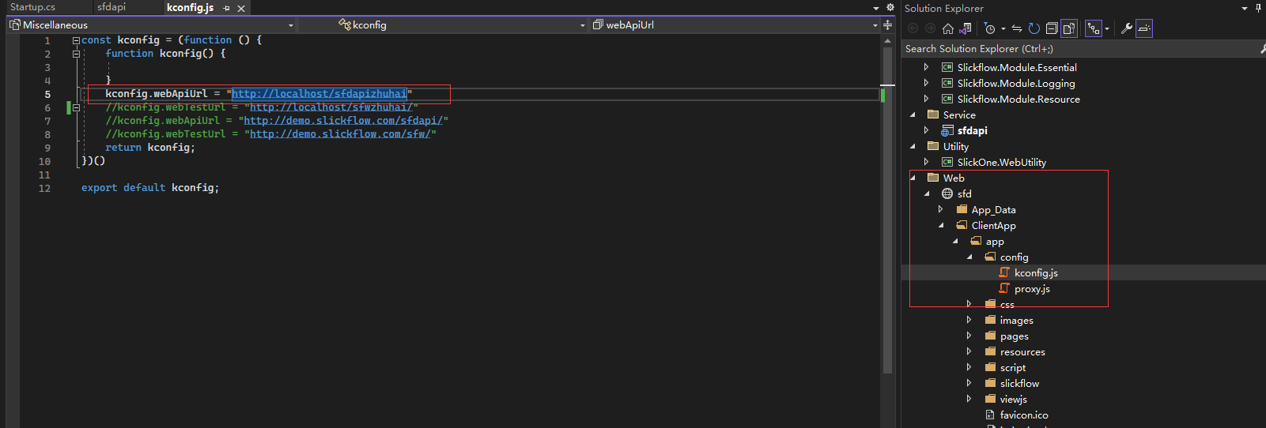
- Run command execution: npm run dev

    - Backend WebAPI service sfdapi
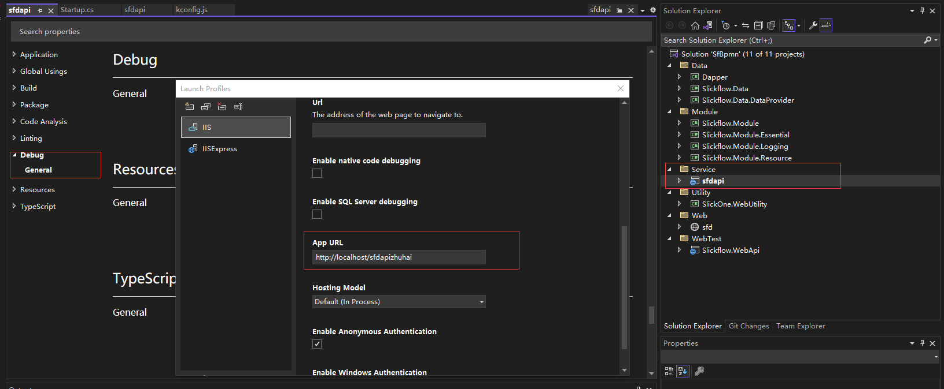
    - database connection string
appsetting.json file

  - Slickflow MvcDemo order process DEMO
- IIS site
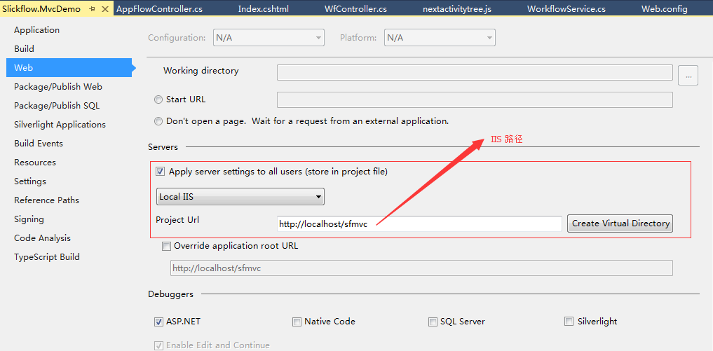
- database connection string
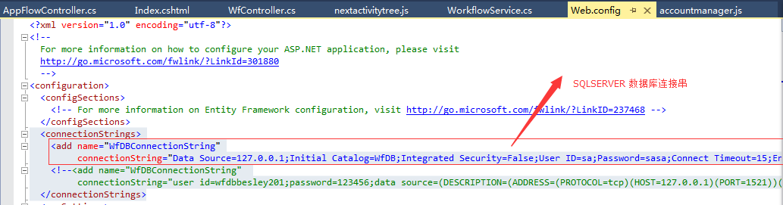
or appsettings.json
  - Slickflow WebDemo leave process DEMO
- IIS site
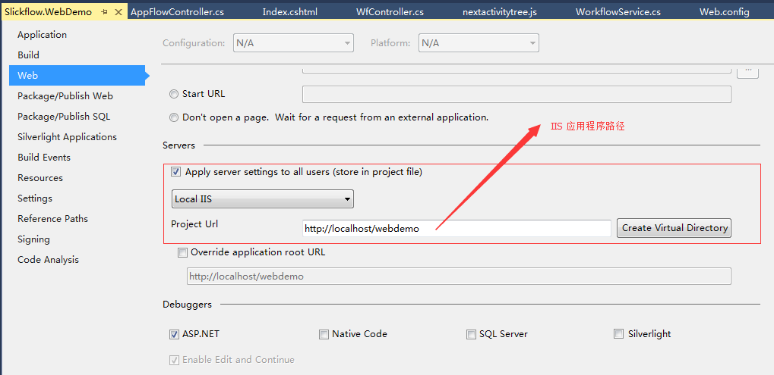
- database connection string


- database environment
  - database creation script
database defaults to the SQLSERVER version, and the script is in the database directory
  - data sheet
SQLSERVER2008 or above is recommended, and the list of engine-related database tables is as follows:
- WfProcess — Process definition table
- WfProcessInstance — process instance table
- WfActivityInstance — activity instance table
- WfTransitionInstance — Activity transition table
- WfTasks — list of tasks
- WfLogs — log table
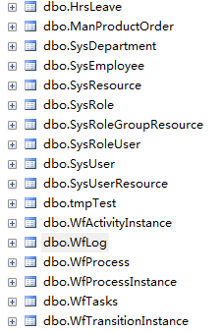
- Recommended Use
Enterprise customers are recommended to use Enterprise, Ultimate, and Universe. For details on the specific versions, you can browse the official website and see the product list.
http://www.slickflow.net/product/index

